**LOUVER PEDESTAL FANS:**

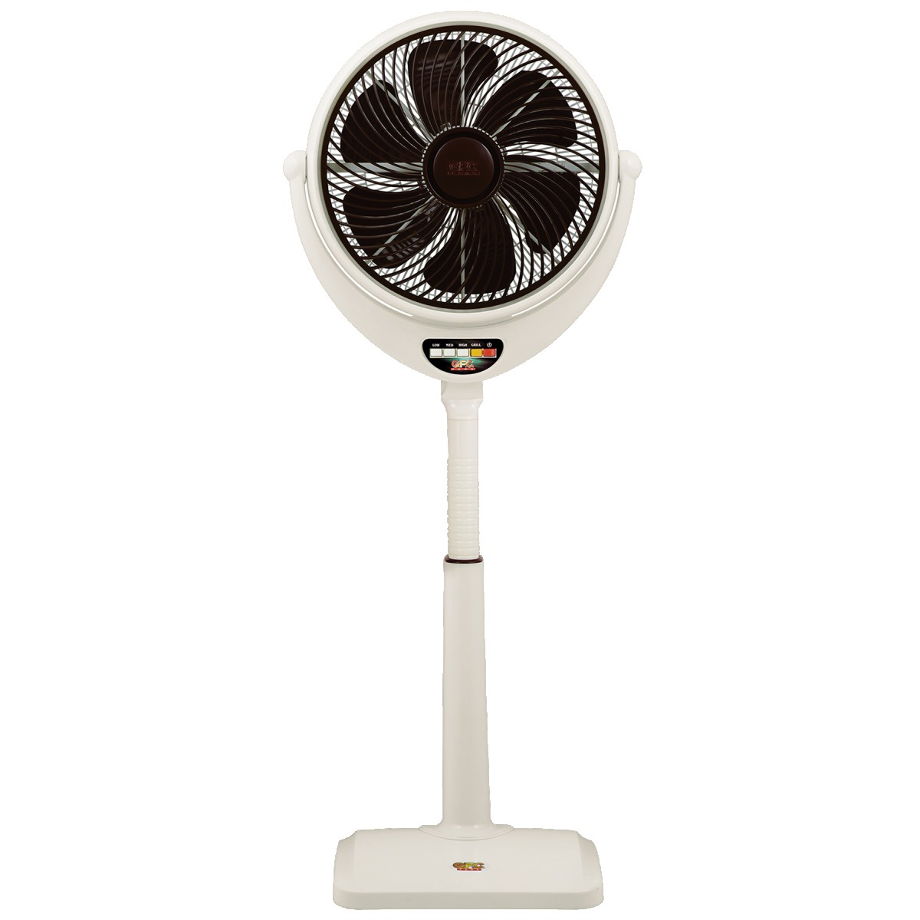

**Price: 9,450.00**

Louver Pedestal Fans are a versatile and effective cooling solution, combining the benefits of both pedestal and louver fans. Their sleek design allows for adjustable height settings, making them perfect for various spaces, from homes to offices. The louvered structure enables focused airflow, directing cool air exactly where needed, while also adding a touch of modern style to any room. With their powerful motors and quiet operation, Louver Pedestal Fans provide efficient and comfortable cooling.

**Key features of louver pedestal fans include:**

* **Adjustable Louvers** – Allows precise control of airflow direction.
* **Height Adjustment** – Pedestal design enables customizable height for optimal cooling.
* **Multiple Speed Settings** – Offers different airflow speeds for varying comfort levels.
* **Oscillation Function** – Provides wide-area airflow for even distribution.
* **Quiet Operation** – Designed for minimal noise during use.
* **Energy Efficient** – Consumes less power while delivering effective cooling.
* **Sleek Design** – Modern, stylish look that complements various spaces.